T-Line Homework 3 (15 Points)
(jas T-Line HW3.docx 9/01/2022)

Use units and clearly label answers using 3 or 4 significant digits where appropriate. Show your work so that if necessary partial credit can be awarded.

- Using the method and equation given in the Ulaby text for a shorted transmission line, calculate the minimum line length in cm that would results in a transmission line input impedance equivalent to that of a 10 nH inductor for a shorted 50 Ω transmission line operating at 1.2 GHz with u_{p} = 0.7c. (Hint: Answer should be between 2 to 4 cm.)
(6 points.)

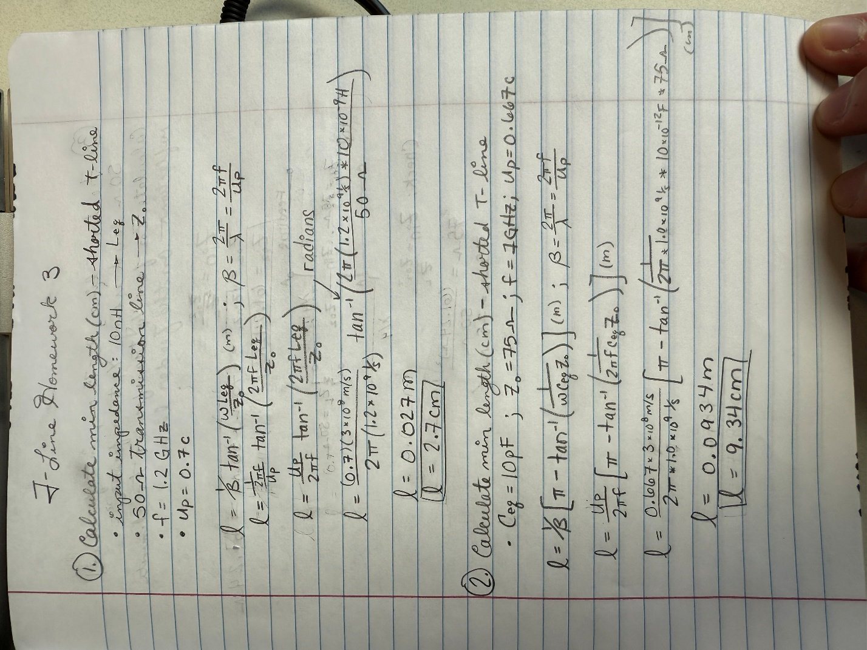

- Using the method and equation given in the Ulaby text for a shorted transmission line, calculate the minimum line length in cm that would results in a transmission line input impedance equivalent to that of a 10 pf capacitor for a shorted 75 Ω transmission line operating at 1 GHz with u_{p} = 0.667c. (Hint: Answer should be between 8 to 10 cm.)
(6 points.)



- A feeder transmission line with characteristic impedance of 75 Ω is to be interfaced to a 50 Ω load using a λ/4 transformer. Calculate the characteristic impedance Z₀₂ necessary for a λ/4 transformer to eliminate reflections on the feeder line including units. (Hint: You can check your answer to this problem by means of the original expression.)
(3 points.)

